Standard Laboratory Weight
# Source: AI Source: Provided by: [Data Path: Persons Table -> ID Column: 1, Name_En Column: Motasem Essam] -> From: [ChatGPT] on [7/17/2026]
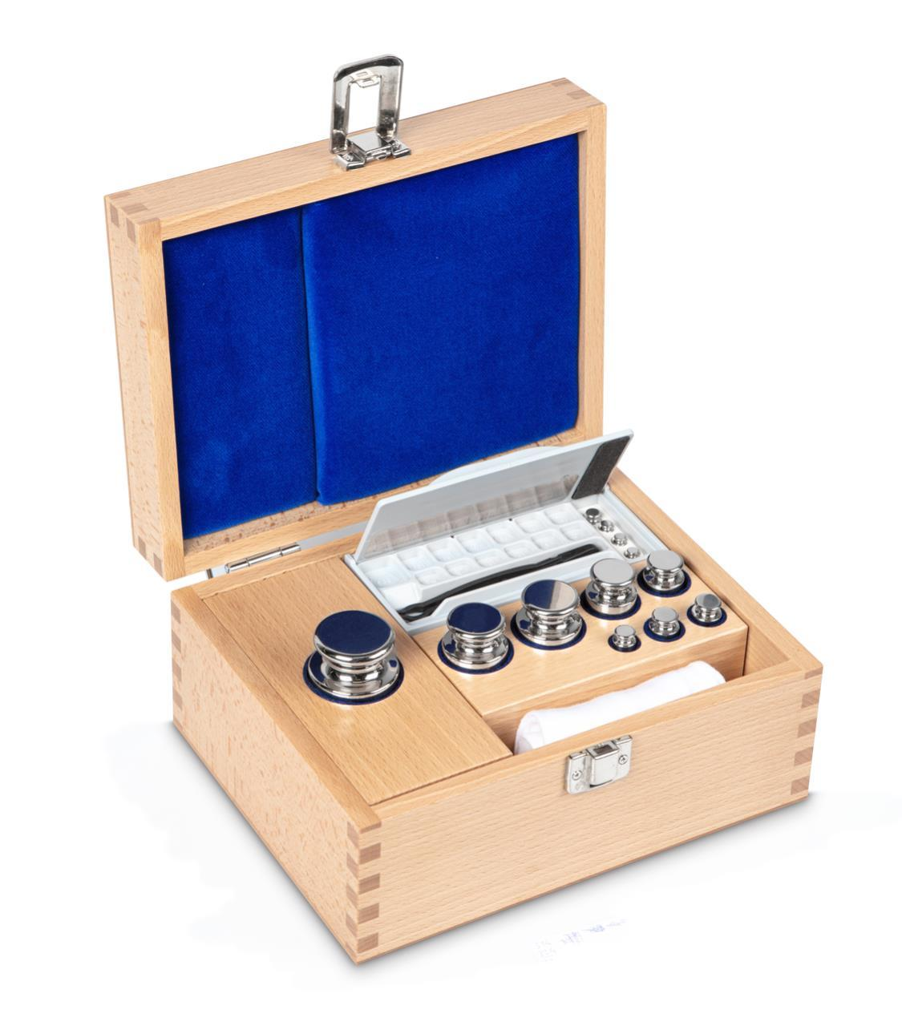
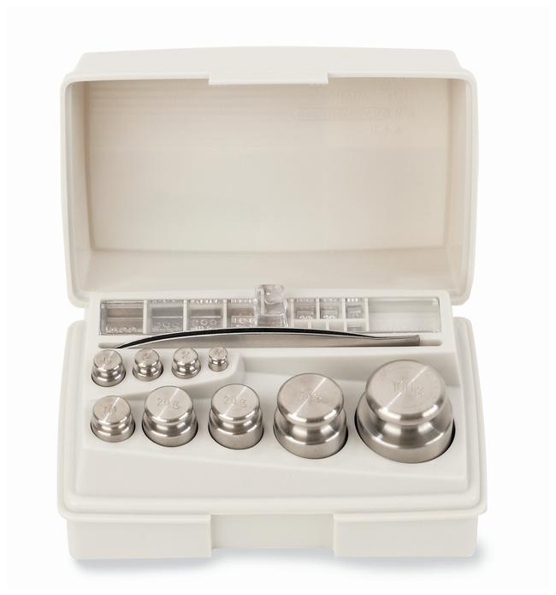
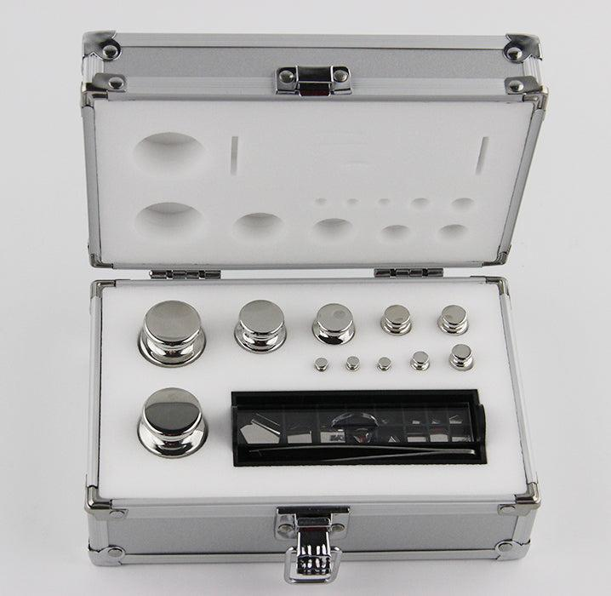
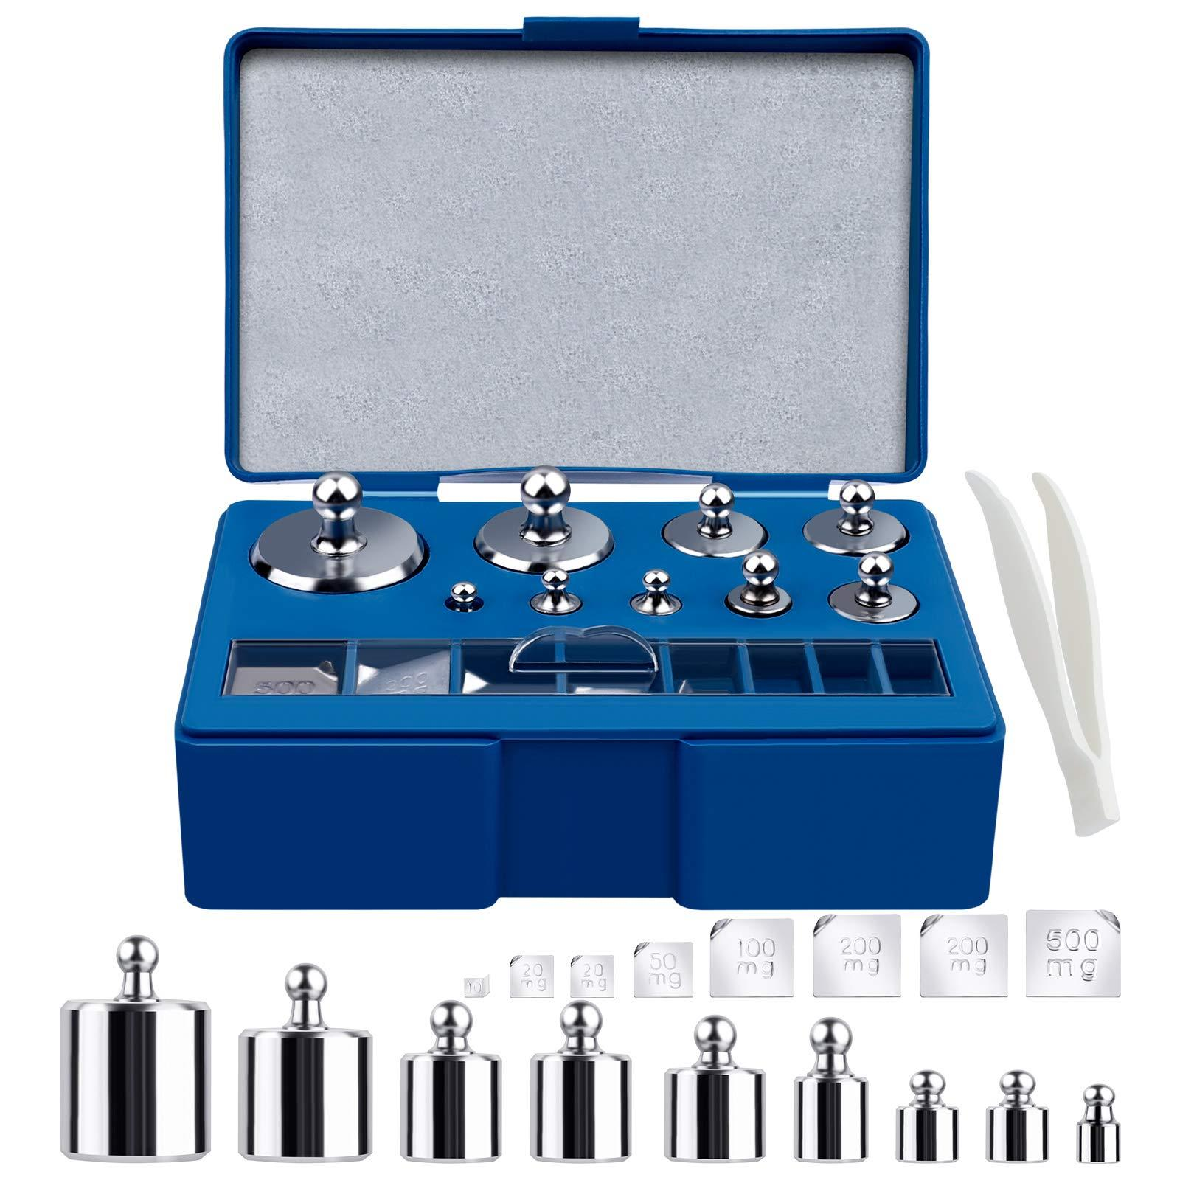
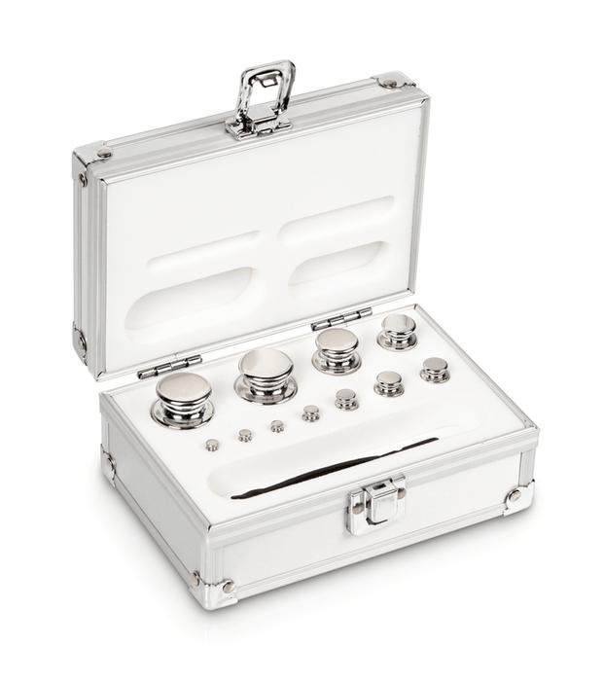
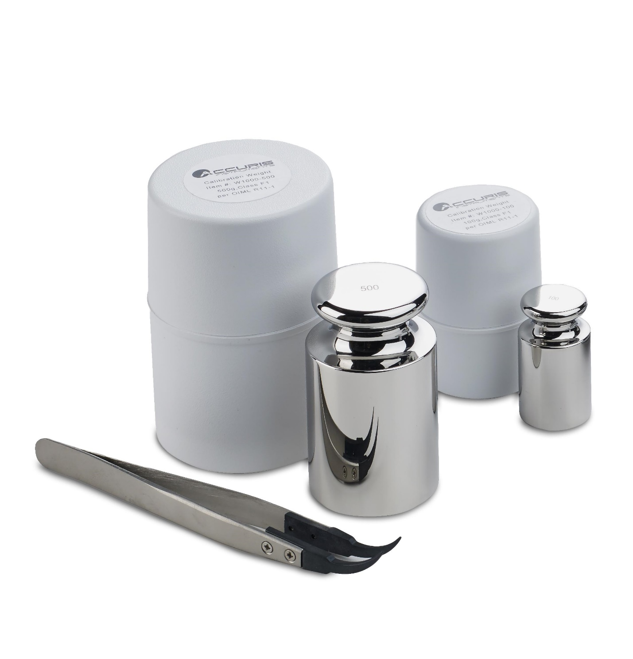
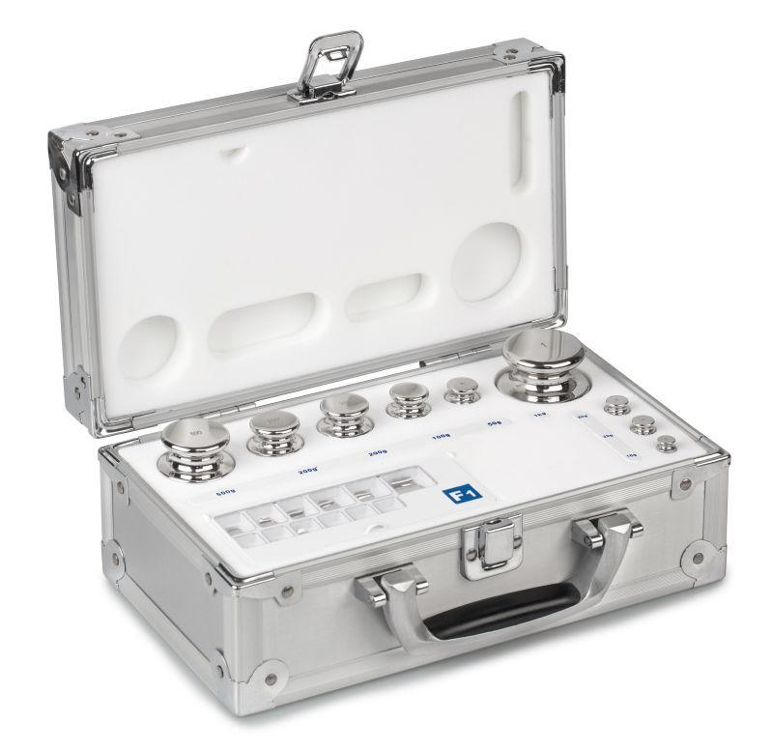
A Standard Laboratory Weight (also called a Calibration Weight, Mass Standard, or Reference Weight) is a precision mass standard used to calibrate, verify, and test weighing instruments such as balances and scales.
Unlike a weighing scale or balance, a standard laboratory weight does not measure mass. Instead, it provides a known reference mass against which weighing instruments are calibrated.

Definition
# Source: AI Source: Provided by: [Data Path: Persons Table -> ID Column: 1, Name_En Column: Motasem Essam] -> From: [ChatGPT] on [7/17/2026]
A Standard Laboratory Weight is a precision-manufactured object with a certified known mass used as a reference for calibrating and verifying balances and weighing instruments.

Purpose
# Source: AI Source: Provided by: [Data Path: Persons Table -> ID Column: 1, Name_En Column: Motasem Essam] -> From: [ChatGPT] on [7/17/2026]
Standard laboratory weights are used to:
- Calibrate balances.
- Verify weighing accuracy.
- Test weighing equipment.
- Maintain traceability to national standards.
- Support laboratory quality control.
- Meet ISO and metrology requirements.

Principle of Operation
# Source: AI Source: Provided by: [Data Path: Persons Table -> ID Column: 1, Name_En Column: Motasem Essam] -> From: [ChatGPT] on [7/17/2026]
A standard laboratory weight works as a reference mass.
The balance compares the unknown object's mass with the certified reference mass.
No electronics are involved in the weight itself.

Main Components
# Source: AI Source: Provided by: [Data Path: Persons Table -> ID Column: 1, Name_En Column: Motasem Essam] -> From: [ChatGPT] on [7/17/2026]
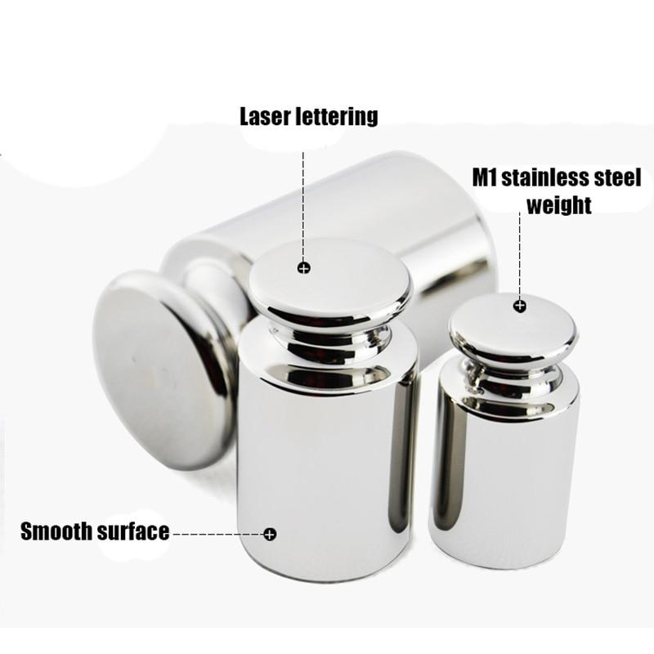
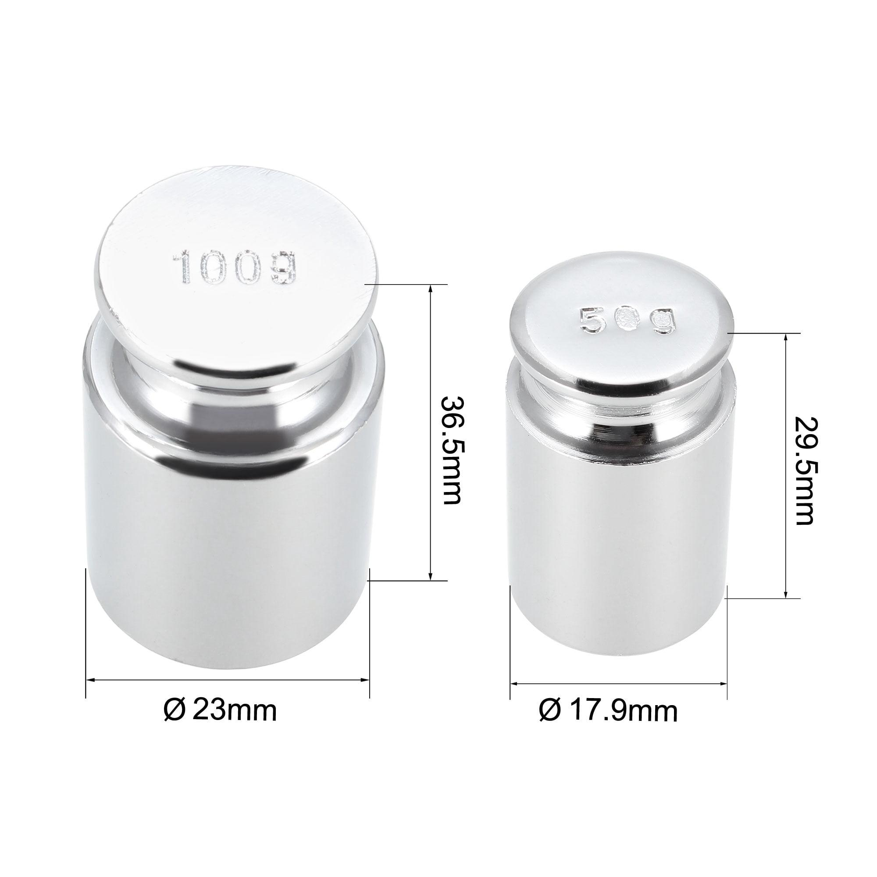
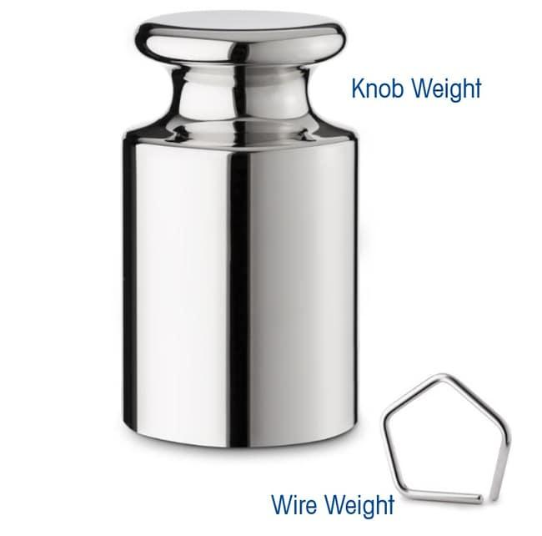
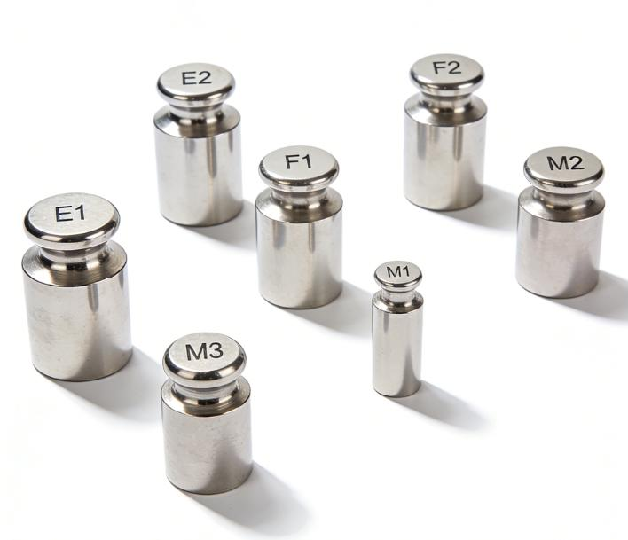
A typical laboratory weight consists of:
- Precision metal body
- Highly polished surface
- Identification marking
- Protective storage case
- Calibration certificate (for certified weights)

Types of Standard Laboratory Weights

1. Knob Weights
# Source: AI Source: Provided by: [Data Path: Persons Table -> ID Column: 1, Name_En Column: Motasem Essam] -> From: [ChatGPT] on [7/17/2026]
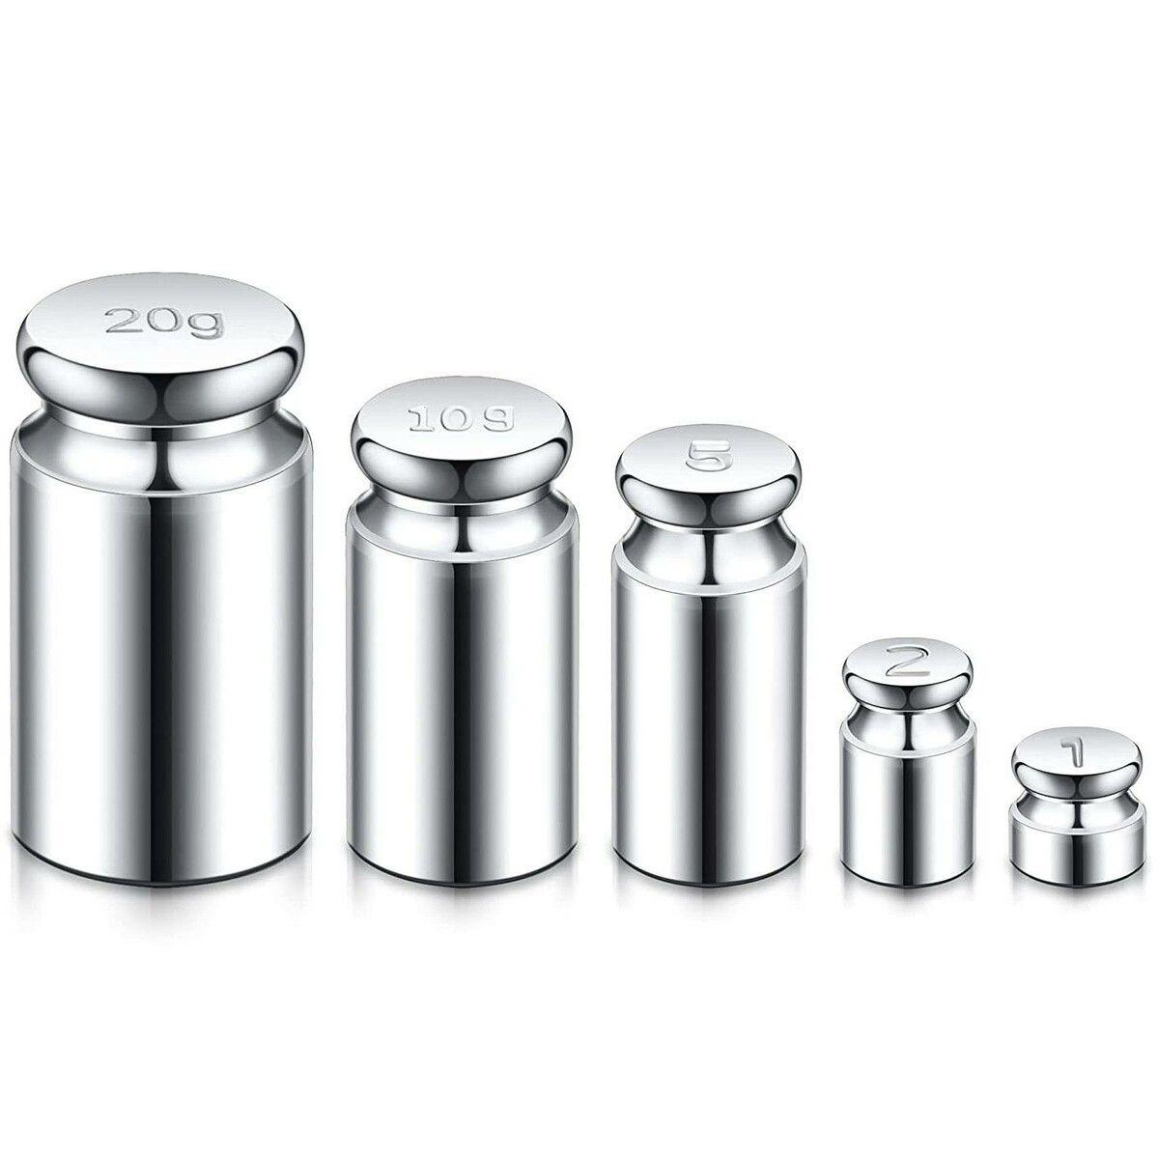
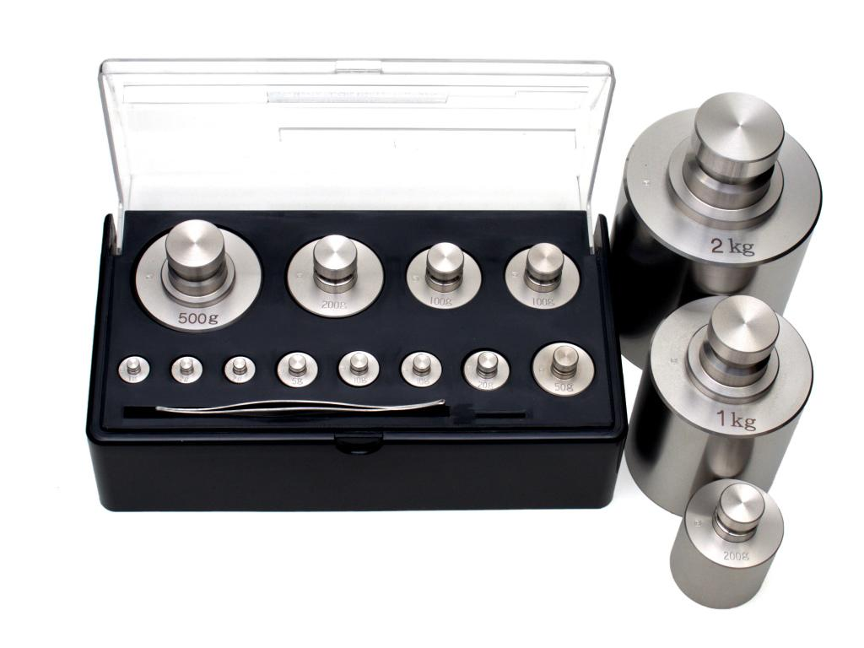
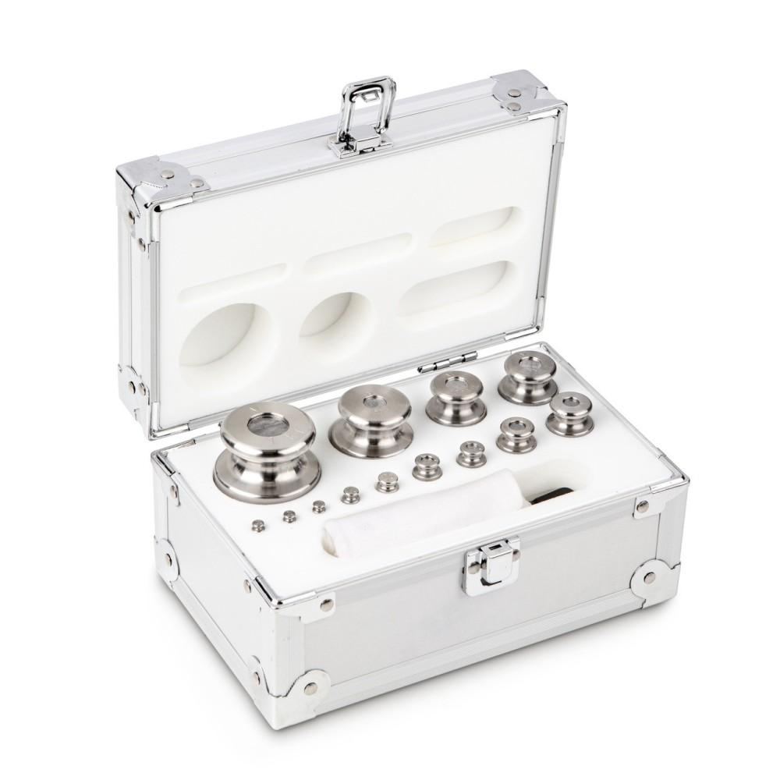
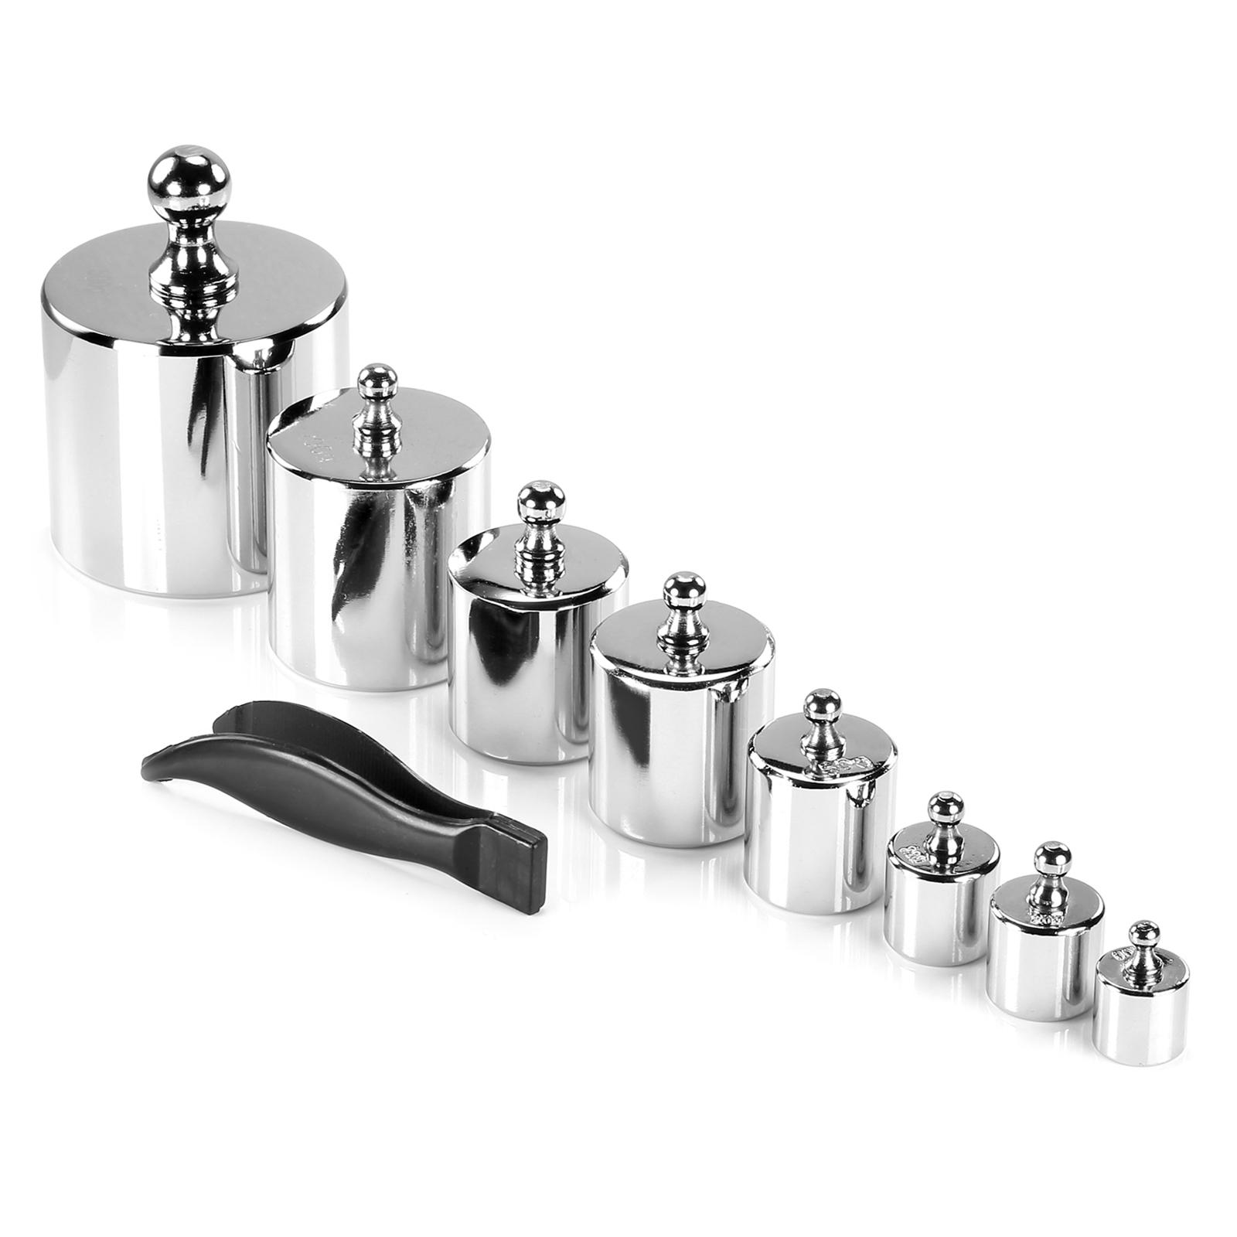
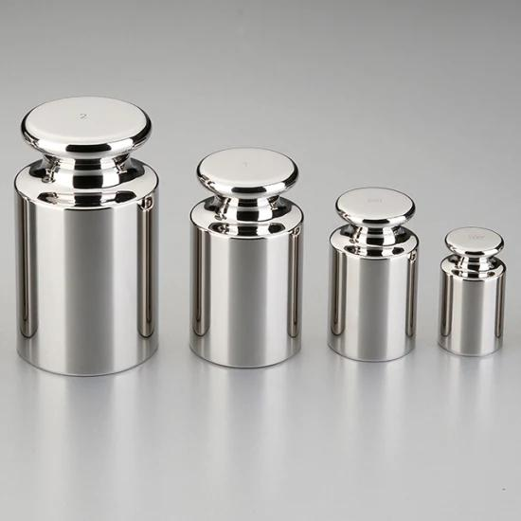
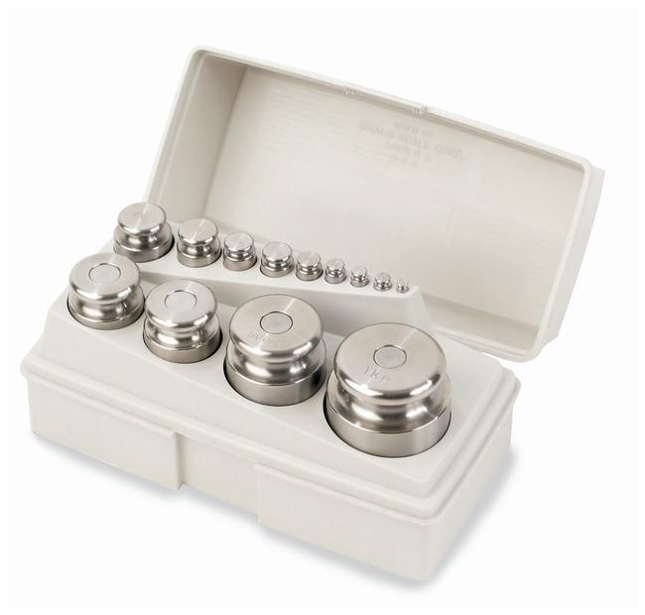
Description
Cylindrical weights with a knob on top for easy handling.
Applications
- General laboratory calibration
- Industrial balances
- Precision weighing

2. Slotted Weights
# Source: AI Source: Provided by: [Data Path: Persons Table -> ID Column: 1, Name_En Column: Motasem Essam] -> From: [ChatGPT] on [7/17/2026]
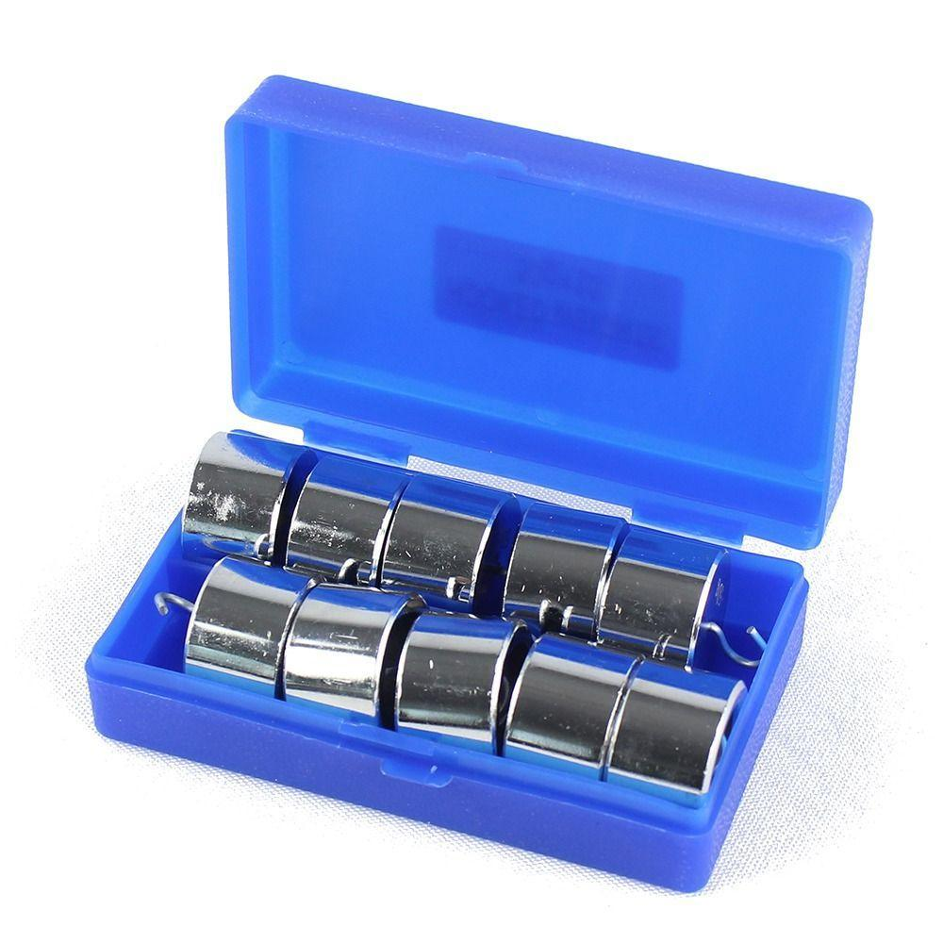
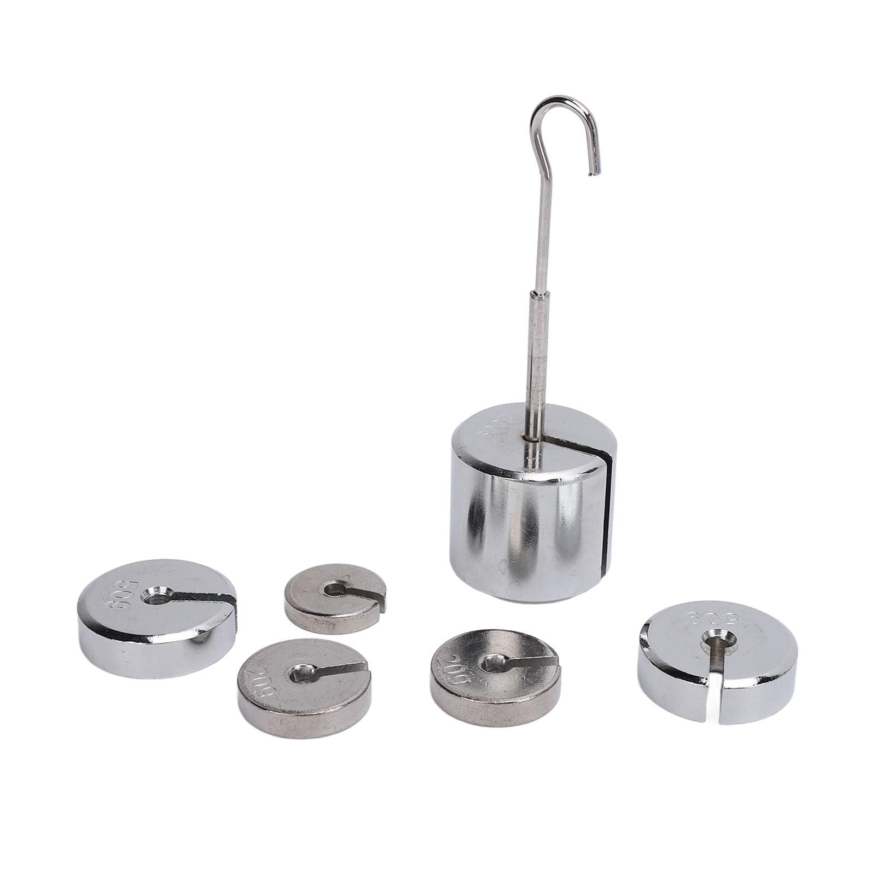
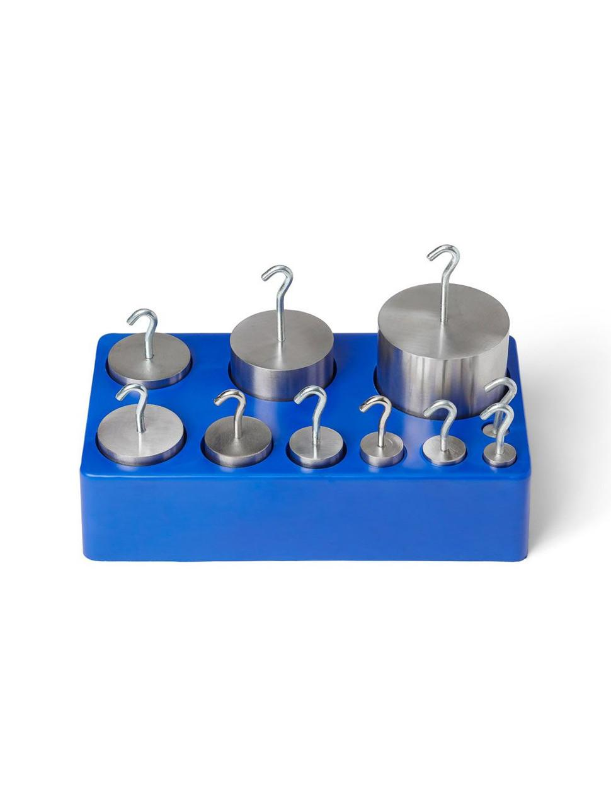
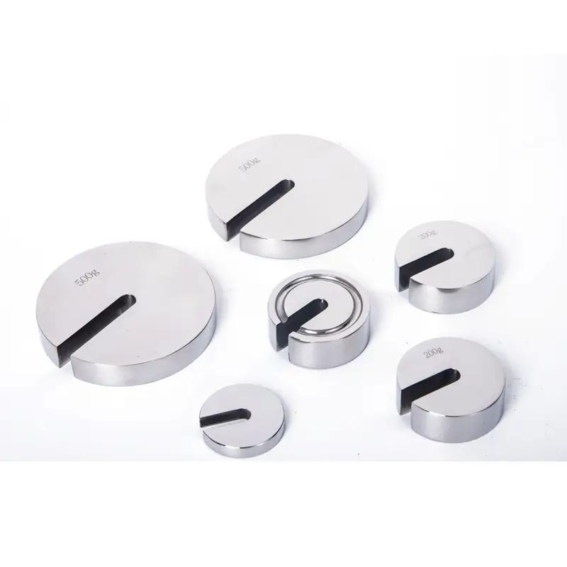
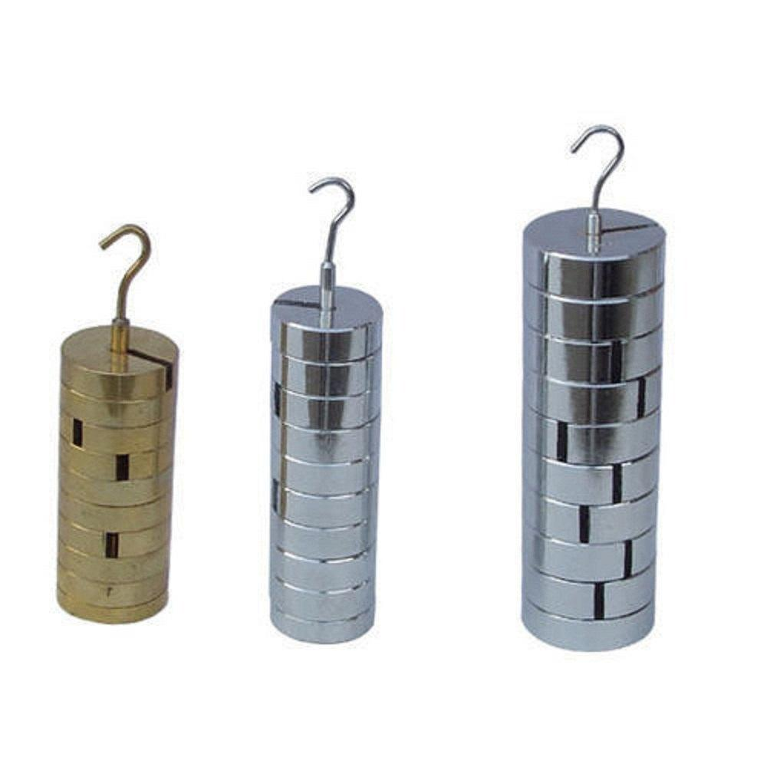
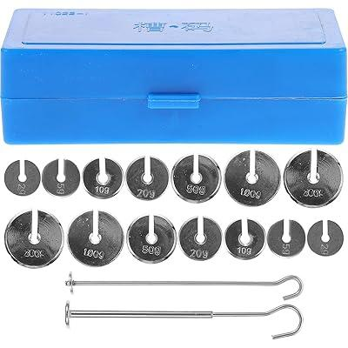
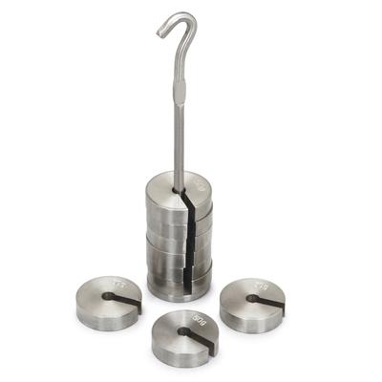
Description
Weights with a central slot that allows stacking on a weight hanger.
Applications
- Physics laboratories
- Force experiments
- Educational demonstrations

3. Sheet (Flat) Weights
# Source: AI Source: Provided by: [Data Path: Persons Table -> ID Column: 1, Name_En Column: Motasem Essam] -> From: [ChatGPT] on [7/17/2026]
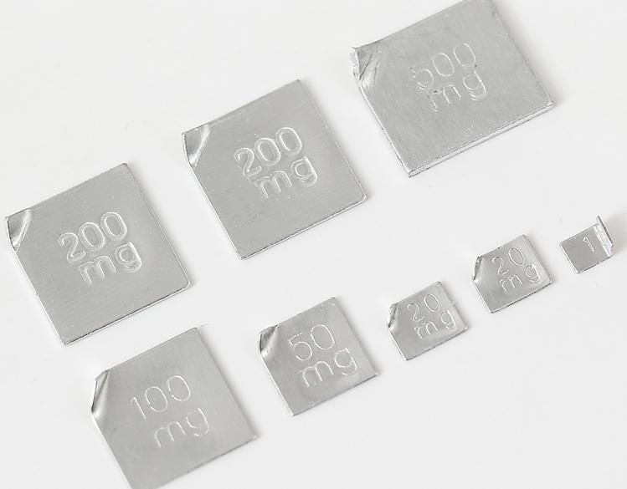
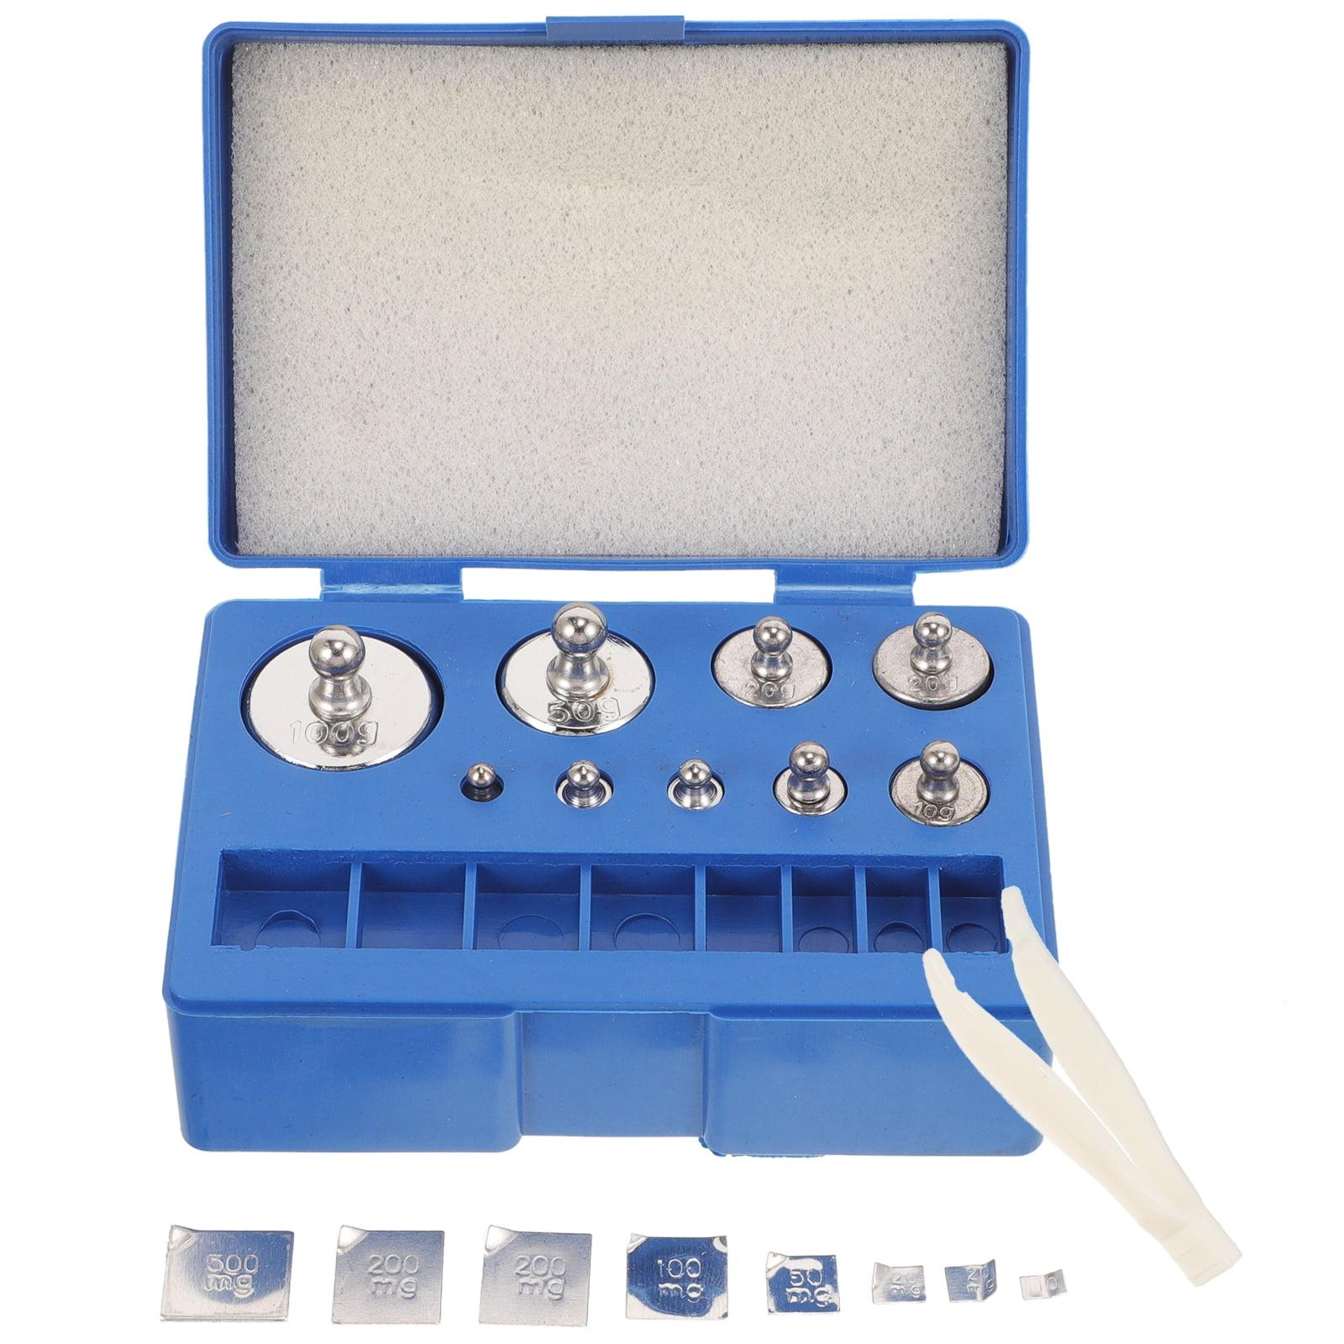
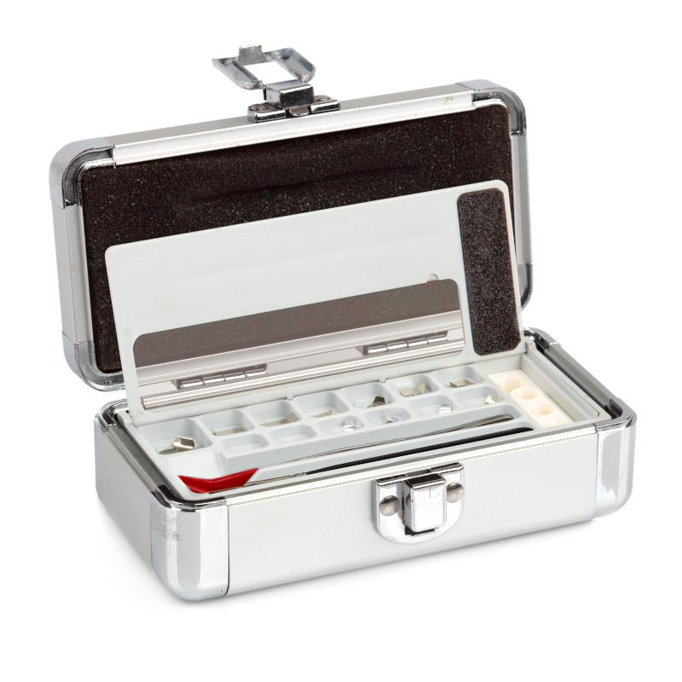
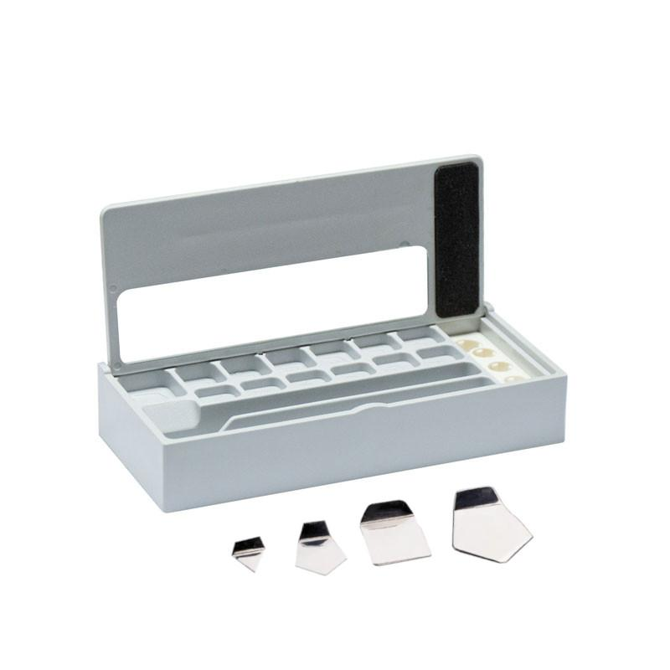
Description
Thin stainless-steel weights used for very small masses.
Applications
- Analytical balances
- Microbalances
- Precision laboratories

4. Wire Weights
# Source: AI Source: Provided by: [Data Path: Persons Table -> ID Column: 1, Name_En Column: Motasem Essam] -> From: [ChatGPT] on [7/17/2026]
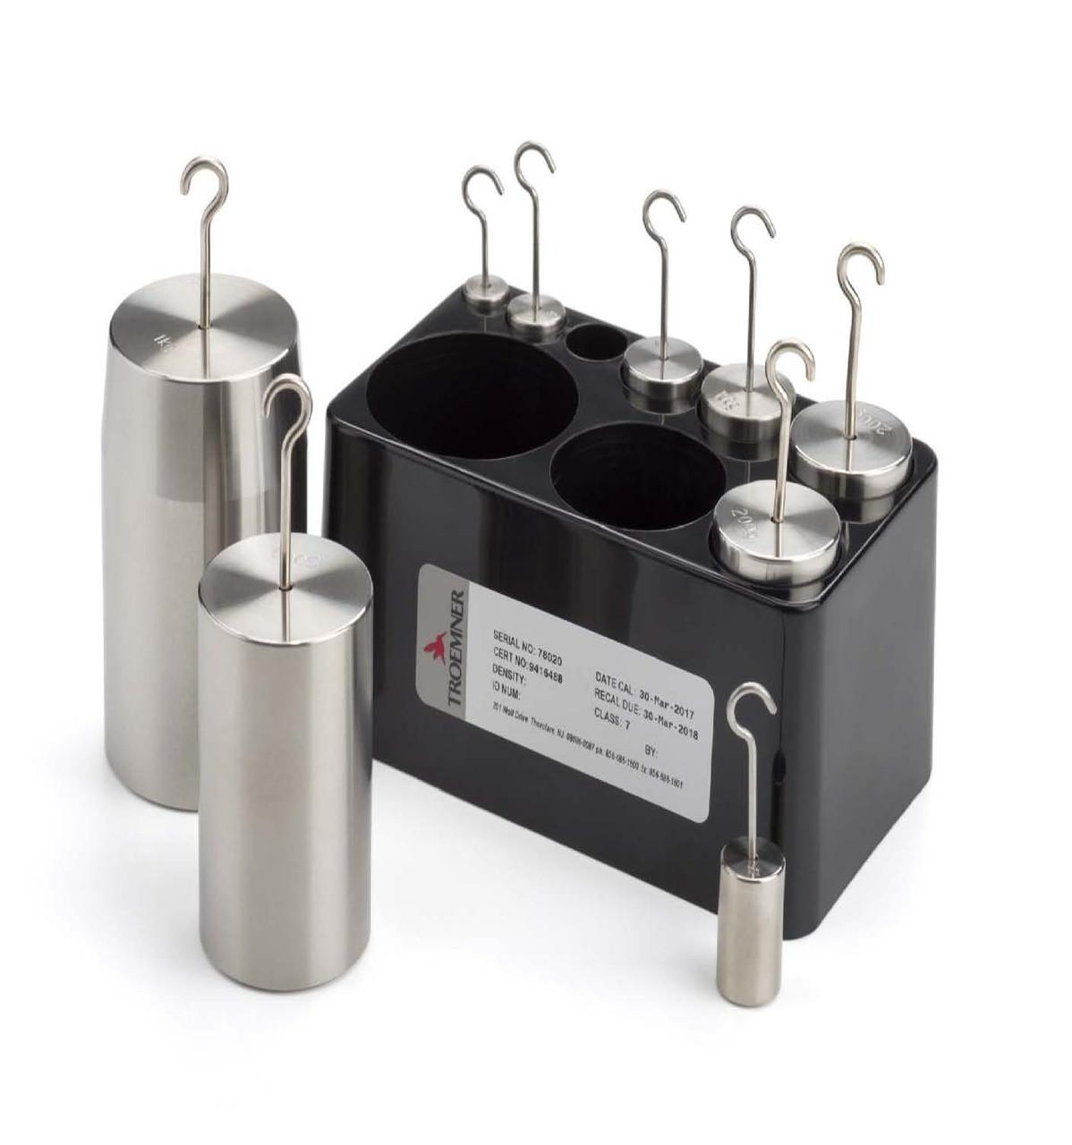
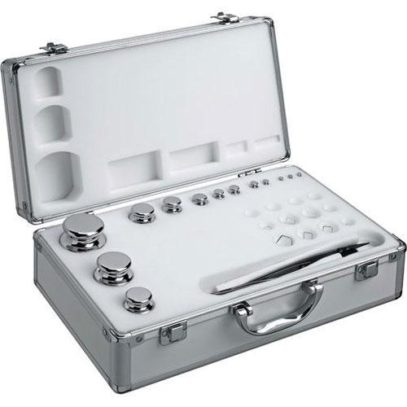
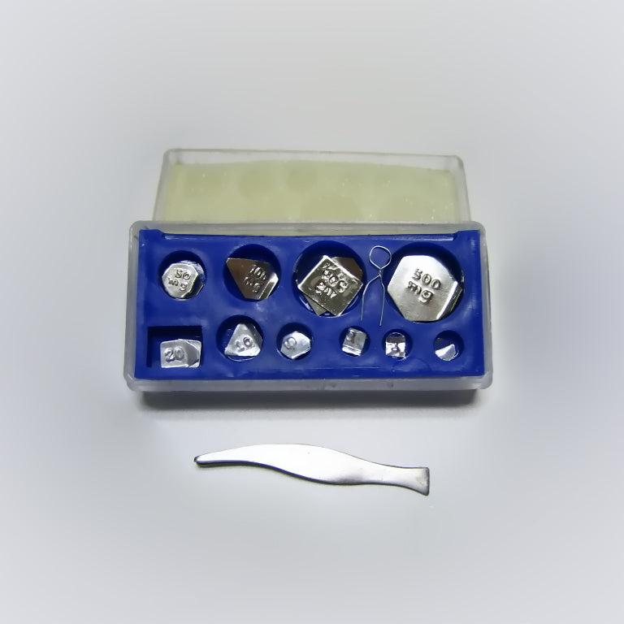
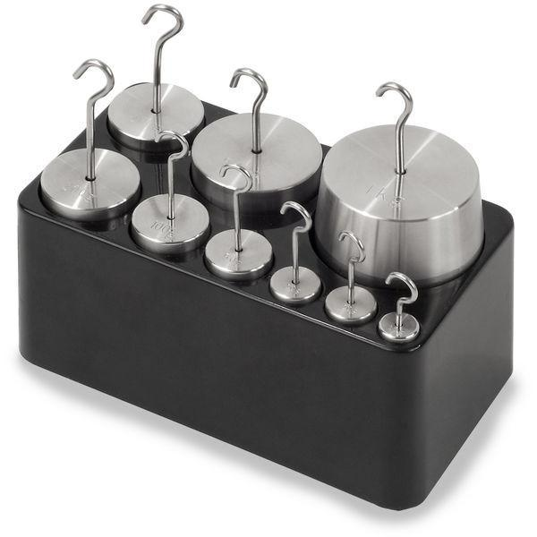
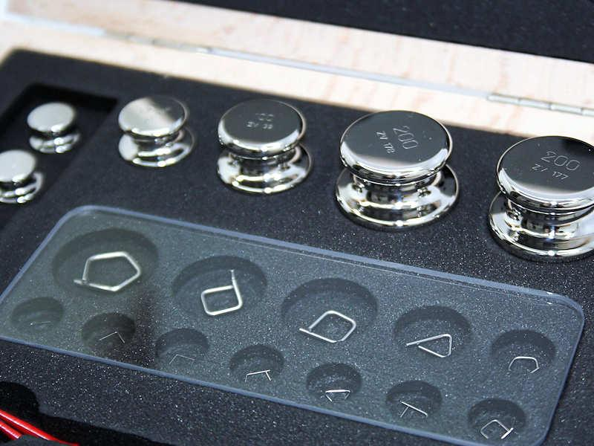
Description
Fine wire-shaped weights used for milligram-level calibration.
Applications
- Analytical chemistry
- Pharmaceutical laboratories
- High-precision measurements

OIML Accuracy Classes
# Source: AI Source: Provided by: [Data Path: Persons Table -> ID Column: 1, Name_En Column: Motasem Essam] -> From: [ChatGPT] on [7/17/2026]
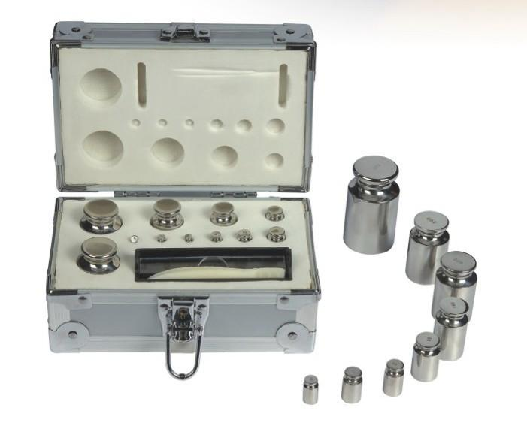
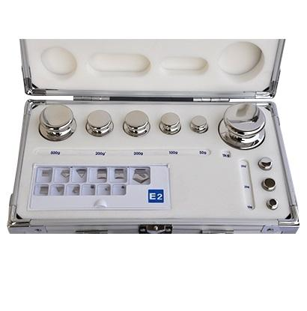
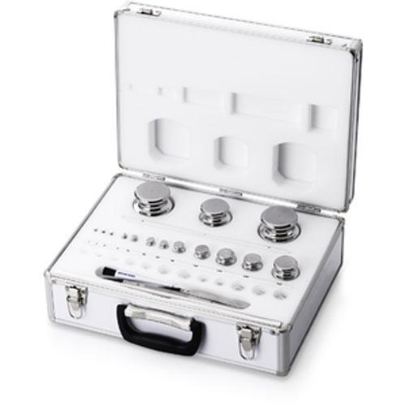
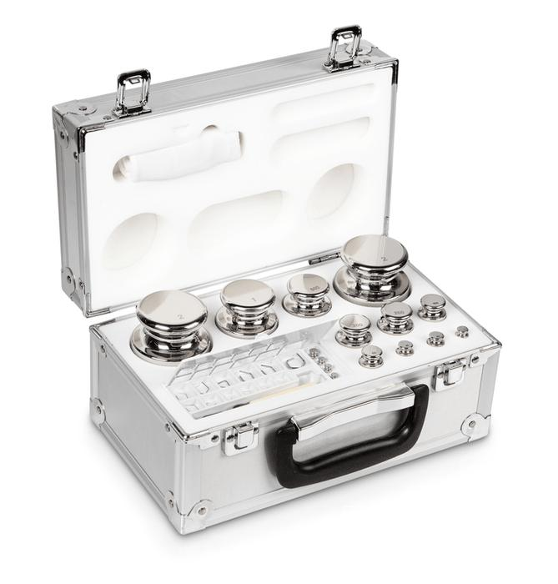
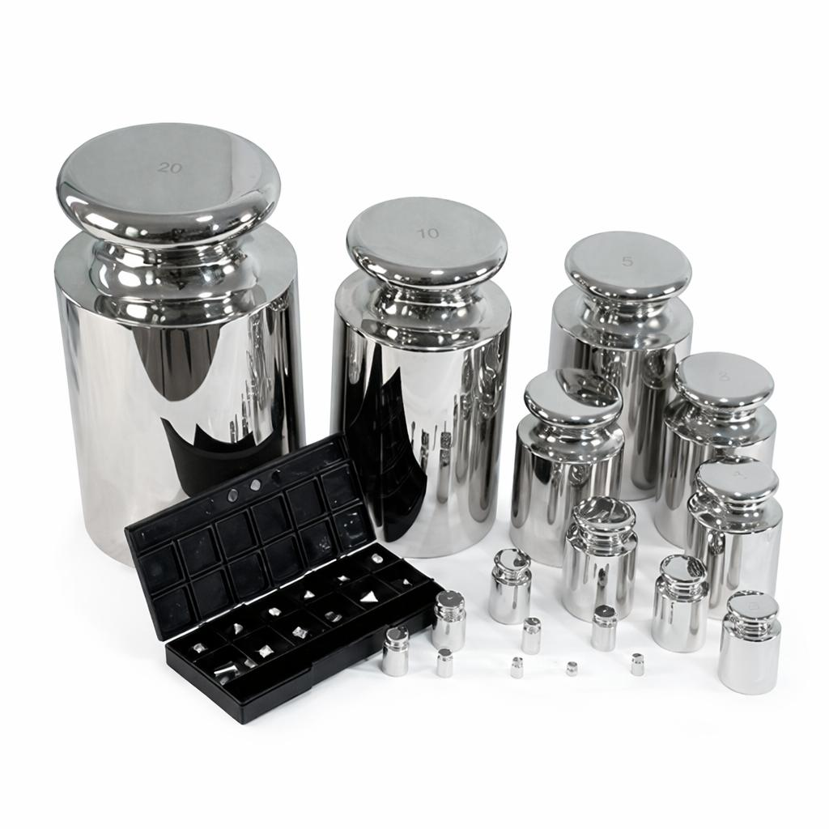
Laboratory weights are classified according to OIML R111.
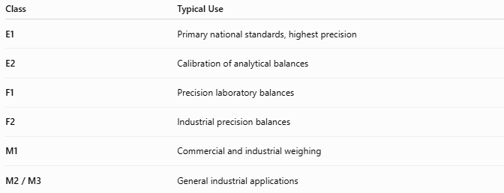
Class | Typical Use
E1 | Primary national standards, highest precision
E2 | Calibration of analytical balances
F1 | Precision laboratory balances
F2 | Industrial precision balances
M1 | Commercial and industrial weighing
M2 / M3 | General industrial applications

Materials
# Source: AI Source: Provided by: [Data Path: Persons Table -> ID Column: 1, Name_En Column: Motasem Essam] -> From: [ChatGPT] on [7/17/2026]
Common materials include:
- Stainless steel
- Non-magnetic stainless steel
- Nickel-plated brass
- Aluminum (small weights)

Measuring Units
# Source: AI Source: Provided by: [Data Path: Persons Table -> ID Column: 1, Name_En Column: Motasem Essam] -> From: [ChatGPT] on [7/17/2026]
Standard laboratory weights are manufactured in:
- Microgram (µg)
- Milligram (mg)
- Gram (g)
- Kilogram (kg)

Measuring Range
# Source: AI Source: Provided by: [Data Path: Persons Table -> ID Column: 1, Name_En Column: Motasem Essam] -> From: [ChatGPT] on [7/17/2026]
Although laboratory weights do not measure, they are manufactured in standardized mass values.
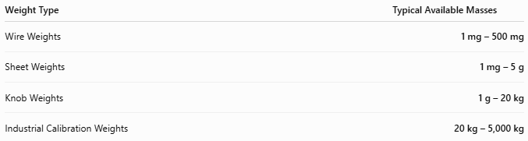
Weight Type | Typical Available Masses
Wire Weights | 1 mg – 500 mg
Sheet Weights | 1 mg – 5 g
Knob Weights | 1 g – 20 kg
Industrial Calibration Weights | 20 kg – 5,000 kg

Resolution
# Source: AI Source: Provided by: [Data Path: Persons Table -> ID Column: 1, Name_En Column: Motasem Essam] -> From: [ChatGPT] on [7/17/2026]
Standard laboratory weights do not have a display, so they do not have a measurement resolution.
Instead, they are manufactured in discrete nominal mass values.
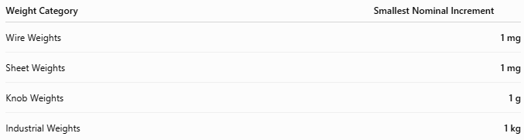
Weight Category | Smallest Nominal Increment
Wire Weights | 1 mg
Sheet Weights | 1 mg
Knob Weights | 1 g
Industrial Weights | 1 kg

Accuracy
# Source: AI Source: Provided by: [Data Path: Persons Table -> ID Column: 1, Name_En Column: Motasem Essam] -> From: [ChatGPT] on [7/17/2026]
The accuracy of a standard laboratory weight is determined by its OIML accuracy class, which specifies the maximum permissible error.
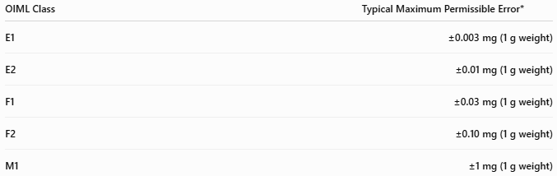
OIML Class | Typical Maximum Permissible Error*
E1 | ±0.003 mg (1 g weight)
E2 | ±0.01 mg (1 g weight)
F1 | ±0.03 mg (1 g weight)
F2 | ±0.10 mg (1 g weight)
M1 | ±1 mg (1 g weight)
*Maximum permissible error depends on the nominal mass; larger weights have larger allowable tolerances according to OIML R111.
Notes
- E1 and E2 weights are intended for the calibration of high-precision analytical balances.
- F1 and F2 weights are suitable for precision laboratory and industrial balances.
- M1 weights are commonly used for commercial and general industrial calibration.
- Calibration certificates provide the actual conventional mass and measurement uncertainty of certified weights.

How to Use Standard Laboratory Weights
# Source: AI Source: Provided by: [Data Path: Persons Table -> ID Column: 1, Name_En Column: Motasem Essam] -> From: [ChatGPT] on [7/17/2026]
- Clean the balance.
- Use forceps or gloves when handling small precision weights.
- Place the weight gently on the balance.
- Compare the displayed value with the certified value.
- Adjust or calibrate the balance if necessary.

Applications
# Source: AI Source: Provided by: [Data Path: Persons Table -> ID Column: 1, Name_En Column: Motasem Essam] -> From: [ChatGPT] on [7/17/2026]
Standard laboratory weights are used in:
- Calibration laboratories
- Universities
- Pharmaceutical laboratories
- Chemical laboratories
- Food industries
- Industrial quality control
- National metrology institutes

Advantages
# Source: AI Source: Provided by: [Data Path: Persons Table -> ID Column: 1, Name_En Column: Motasem Essam] -> From: [ChatGPT] on [7/17/2026]
Standard laboratory weights:
- Provide highly accurate reference masses.
- Maintain traceability to national and international standards.
- Are durable and corrosion resistant.
- Enable precise balance calibration.

Limitations
# Source: AI Source: Provided by: [Data Path: Persons Table -> ID Column: 1, Name_En Column: Motasem Essam] -> From: [ChatGPT] on [7/17/2026]
Standard laboratory weights:
- Must be handled carefully to avoid contamination.
- Require periodic recalibration.
- Can be damaged by scratches or corrosion.
- High-accuracy classes are expensive.

Sources of Error
# Source: AI Source: Provided by: [Data Path: Persons Table -> ID Column: 1, Name_En Column: Motasem Essam] -> From: [ChatGPT] on [7/17/2026]
Weight Errors
- Surface contamination
- Corrosion
- Mechanical damage
- Wear

User Errors
- Touching weights with bare hands
- Improper handling
- Dropping the weights
- Using dirty weights

Environmental Errors
- Temperature changes
- Air buoyancy
- Humidity
- Dust accumulation

Comparison with Other Mass and Weight Instruments
# Source: AI Source: Provided by: [Data Path: Persons Table -> ID Column: 1, Name_En Column: Motasem Essam] -> From: [ChatGPT] on [7/17/2026]
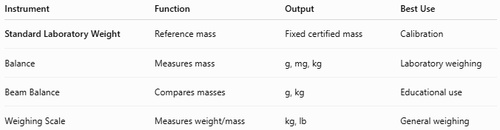
Instrument | Function | Output | Best Use
Standard Laboratory Weight | Reference mass | Fixed certified mass | Calibration
Balance | Measures mass | g, mg, kg | Laboratory weighing
Beam Balance | Compares masses | g, kg | Educational use
Weighing Scale | Measures weight/mass | kg, lb | General weighing

Care and Maintenance
# Source: AI Source: Provided by: [Data Path: Persons Table -> ID Column: 1, Name_En Column: Motasem Essam] -> From: [ChatGPT] on [7/17/2026]
To preserve accuracy:
- Handle with gloves or tweezers.
- Keep weights clean.
- Store in their protective case.
- Avoid touching polished surfaces.
- Recalibrate at recommended intervals.

Common Mistakes
# Source: AI Source: Provided by: [Data Path: Persons Table -> ID Column: 1, Name_En Column: Motasem Essam] -> From: [ChatGPT] on [7/17/2026]
- Handling weights with bare hands.
- Mixing weights from different accuracy classes.
- Storing weights outside their protective case.
- Using damaged or contaminated weights.

Key Points
# Source: AI Source: Provided by: [Data Path: Persons Table -> ID Column: 1, Name_En Column: Motasem Essam] -> From: [ChatGPT] on [7/17/2026]
- A Standard Laboratory Weight is a reference mass, not a measuring instrument.
- It is used to calibrate and verify balances and scales.
- Common forms:
  - Knob Weights
  - Slotted Weights
  - Sheet Weights
  - Wire Weights
- Accuracy is specified by OIML classes (E1, E2, F1, F2, M1, etc.).
- Essential in metrology, laboratories, quality control, and industrial calibration.

Conclusion
# Source: AI Source: Provided by: [Data Path: Persons Table -> ID Column: 1, Name_En Column: Motasem Essam] -> From: [ChatGPT] on [7/17/2026]
A Standard Laboratory Weight is a precision reference artifact used to ensure the accuracy and traceability of weighing instruments. Manufactured to strict OIML standards and available in various designs and accuracy classes, these weights are fundamental to laboratory metrology, industrial quality assurance, scientific research, and calibration services, providing reliable reference masses for accurate and consistent measurements.

